SKILL-3

- To Apply Escape Sequences, Store Command History, Navigate Previous Commands, Navigate Next Commands, Update Input Buffer, Test Recall Functionality.
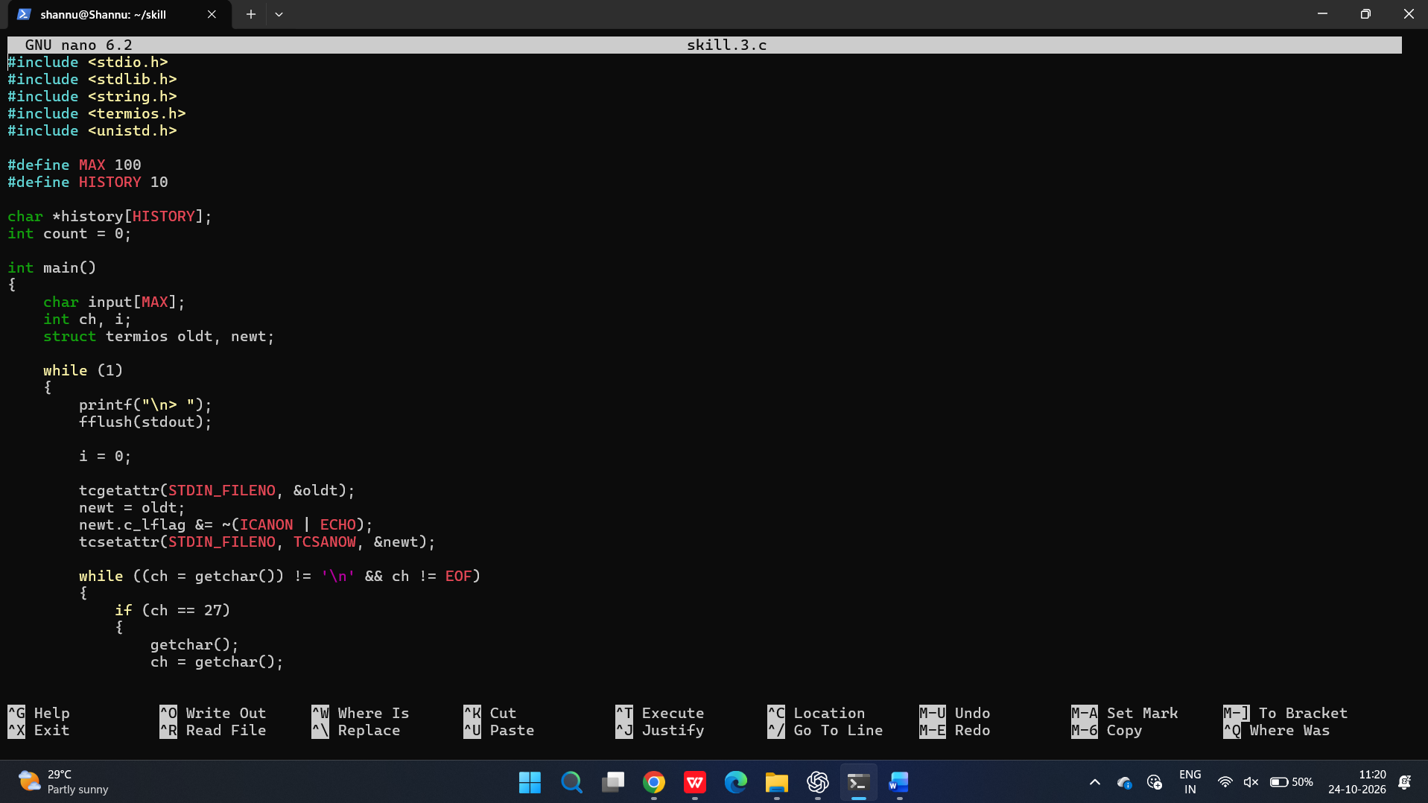
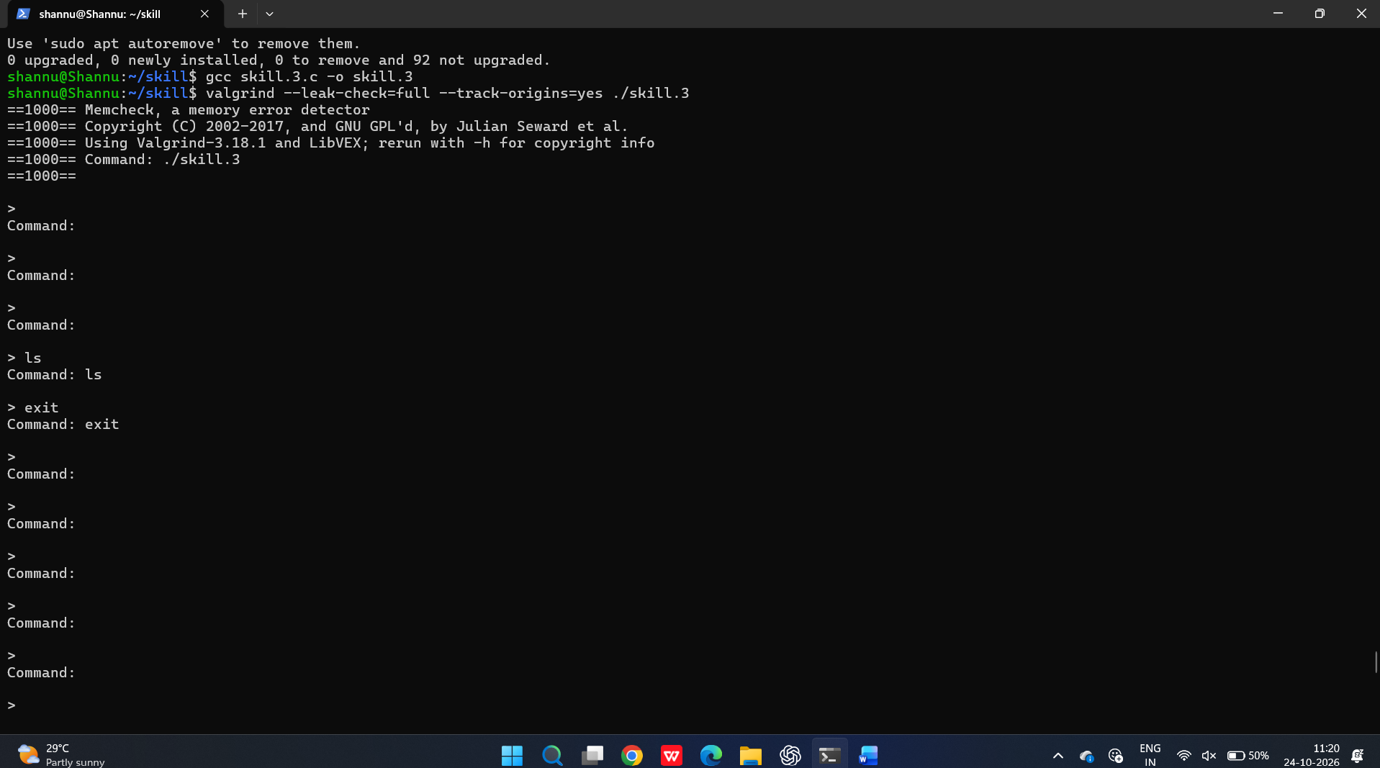
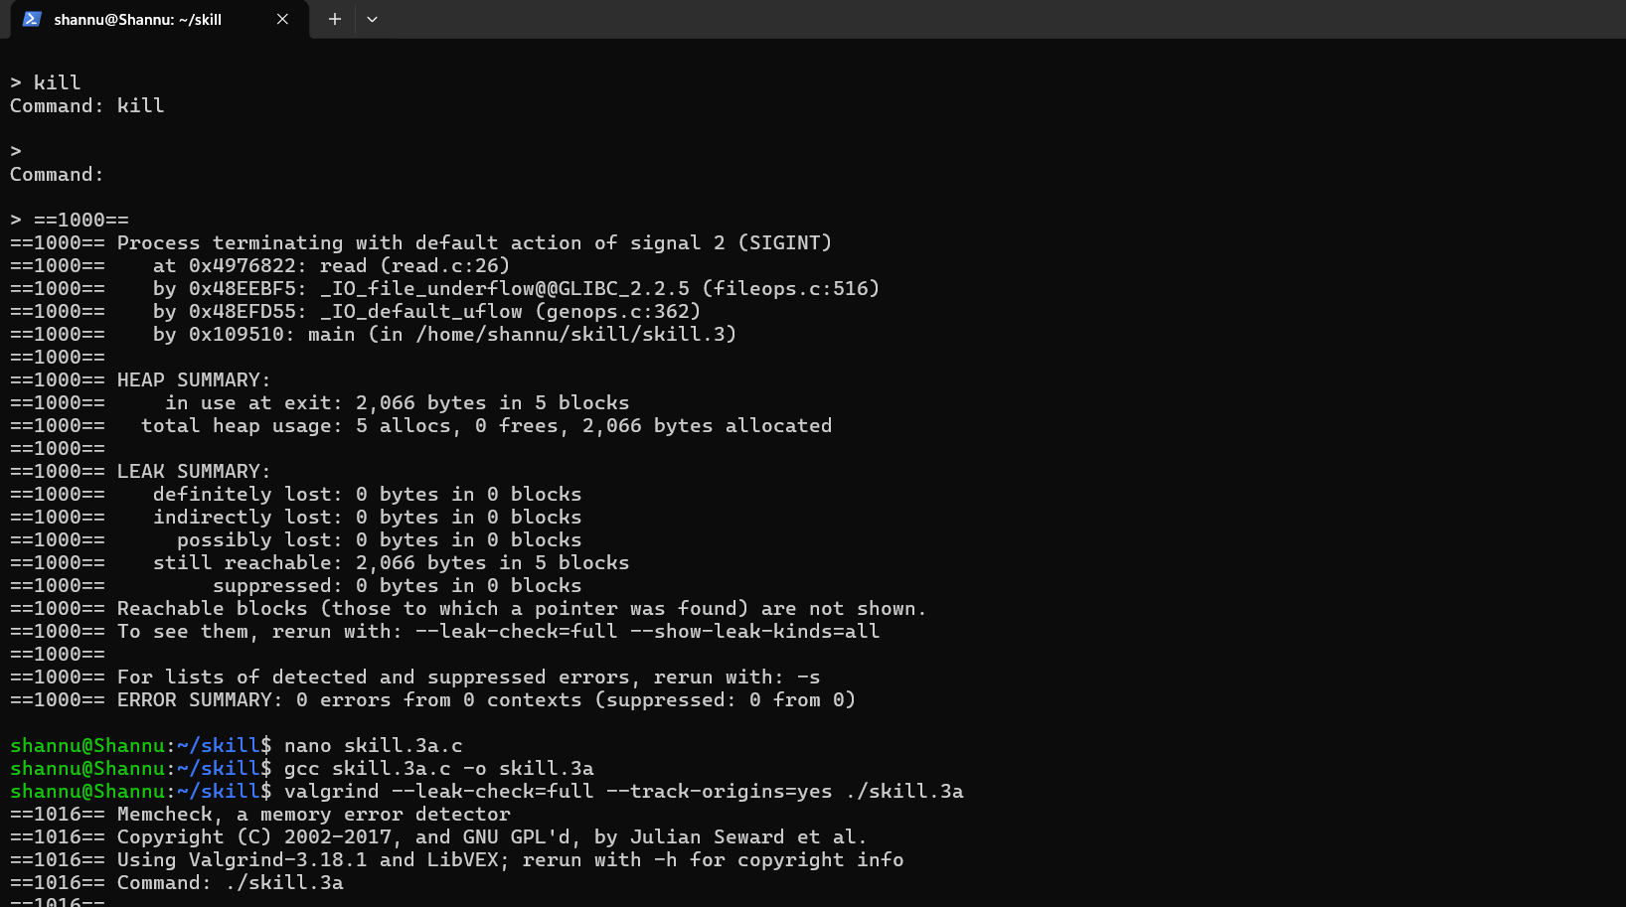

To Allocate Buffers Dynamically, Resize Arrays, Prevent Buffer Overflow, Manage Linked Lists, Release Memory Correctly, Verify with Valgrind.

